**Estimate of COVID-2019 case fatality risk in South Korea accounting for probabilistic delay**

The new corona virus disease 2019 (COVID-2019) is rapidly spreading through the world. With wide variability in available case fatality risk estimates [1], there is considerable uncertainty as to the extent of the threat posed by COVID-19. Direct estimation as the quotient of confirmed cases to deaths tend to underestimate the true value in an early phase of an epidemic as this methods fails to account for the time that passes onset to death [2]. Here, we statistically estimate the case mortality risk of COVID-19 assuming that the time from case confirmation to death is gamma distributed with mean 8.8 days and standard deviation 5.7 days. We base our estimate on South Korean case data which is believed to be the most accurate due to rigorous contact tracing. Based on the available case data until March 19, we estimate the mortality risk as 1.3 % (95% CI 1.0% – 1.7%).

We assume a gamma-distribution of latency time from case confirmation to death equal to the gamma-distributed time from hospitalization to death in Wuhan, China as estimated by Linton et al. [2]. Assuming a fixed case mortality risk we determined the expected number of deaths by summing the expected number of past deaths occurring on each previous day. Each term in the sum is the product of the number of new cases from that day as given by World Health Organization data, the fixed case fatality risk, and the conditional probability that an individual who will die is already dead on the present day, as determined from distribution of latency time from onset to death. By replacing the expected number of deaths with actual number of observed deaths, we obtain an equation that can be solved to give an estimate of the case fatality risk.

To determine indicative confidence intervals, we assumed the estimated case fatality risk to be true and approximated the number of observed deaths on the present day with a normal distribution. We then determine the 2.5% and 97.5% quantiles and determined the estimate case fatality risks corresponding to these quantiles. We take these case fatality risks as the lower and upper bound of a 95% confidence interval. Figure 1 shows how the result of the estimation change as additional case data are included day by day, leading up to our final estimate of 1.3 % (95% CI 1.0% – 1.7%) on March 19. Given the mainly decreasing trend of our estimate over time (blue solid line) and the increasing trend of a direct estimate not accounting for time delays (red solid line), we hypothesize that the actual mortality rate of confirmed cases is somewhere between 1.1%-1.6%.

**References**

1. Gentile, I., & Abenavoli, L. (2020). COVID-19: Perspectives on the Potential Novel Global Threat. *Reviews on Recent Clinical Trials*, 15_ 1.
2. Linton, N. M., Kobayashi, T., Yang, Y., Hayashi, K., Akhmetzhanov, A. R., Jung, S. M., ... & Nishiura, H. (2020). Incubation period and other epidemiological characteristics of 2019 novel coronavirus infections with right truncation: a statistical analysis of publicly available case data*. Journal of Clinical Medicine*, 9: 538.

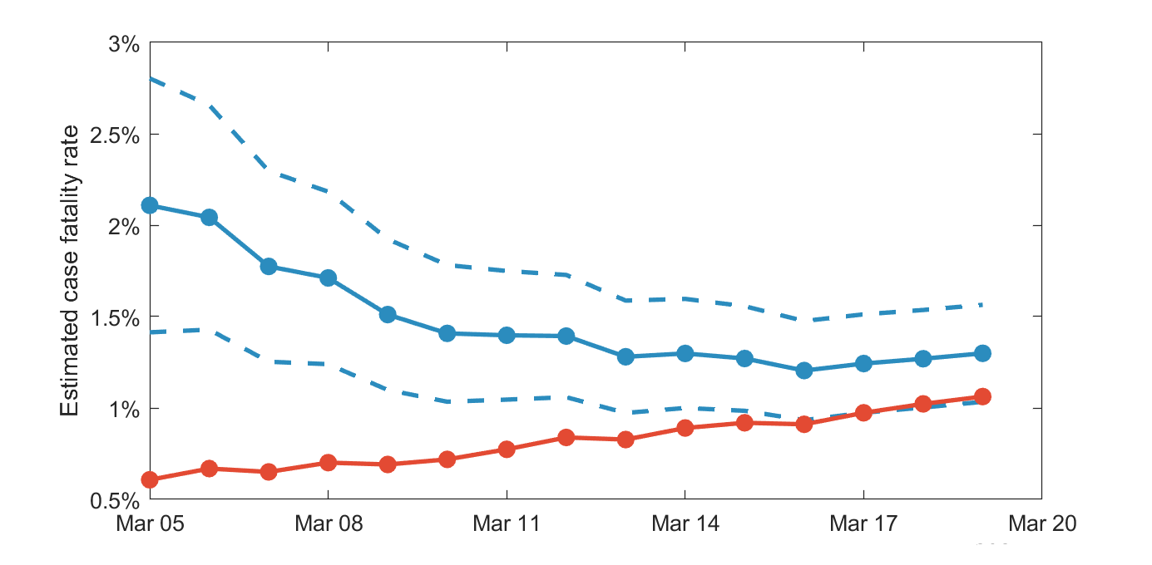

Figure 1: **Estimated case fatality rate as more observations are included day by day**. The solid blue line shows the estimate adjusted for probabilistic delay in time from case confirmation to death. The dashed blue lines are 95% confidence interval. The red solid line is a direct estimate formed as the quotient of deaths to confirmed cases. The final estimates on March 19 are 1.3 % (95% CI 1.0% – 1.7%) in the delay-adjusted case and 1.0 % under direct estimation.